

**App Installation Guide**

**June 2024**

**To download the eMIMSelite app:**

1. For Android Devices – Search for eMIMSelite on the Google Playstore or download via the link: <https://play.google.com/store/apps/details?id=com.mims.elite.prod>.
2. For Apple Devices –Search for eMIMSelite on the Apple Store or download via the link: <https://apps.apple.com/ph/app/emims-elite/id6477411434>.

The eMIMSelite app can be downloaded on the mobile anytime and anywhere when the mobile device is connected to the internet via WiFi/4g/5g.

**To request Mobile Tokens (to login to the eMIMSelite mobile app):**

1. Login to the browser version of eMIMSelite
2. Click on the ‘three-line’ icon on the top right of the main menu.

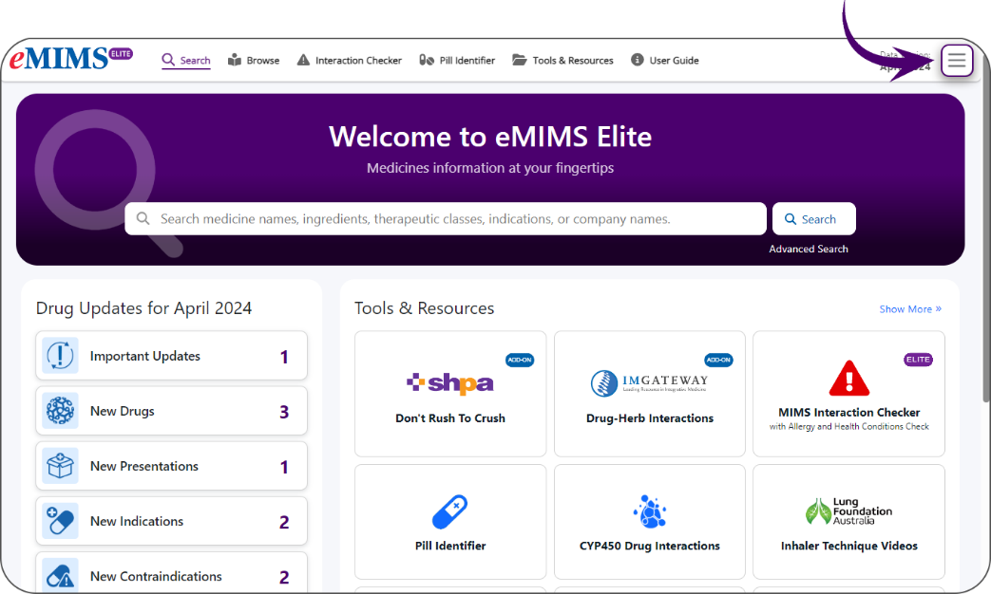

1. Click on the ‘Request Mobile Token’ option.

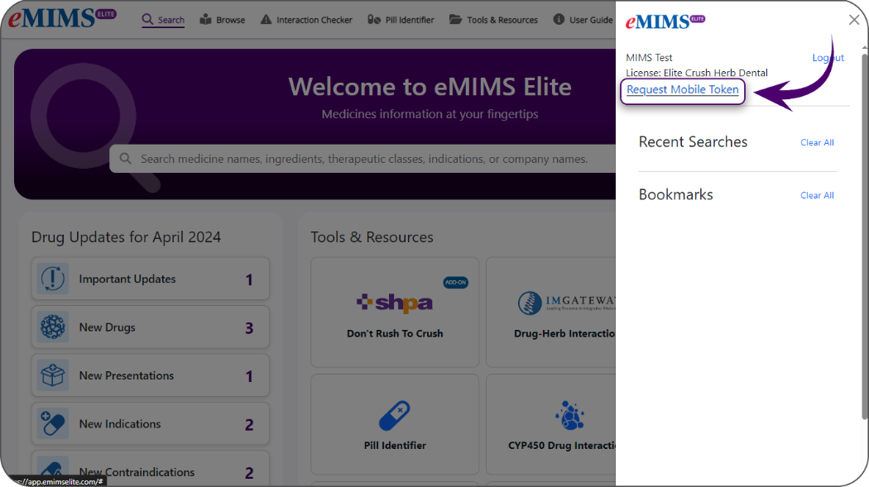

1. Submit your email address.

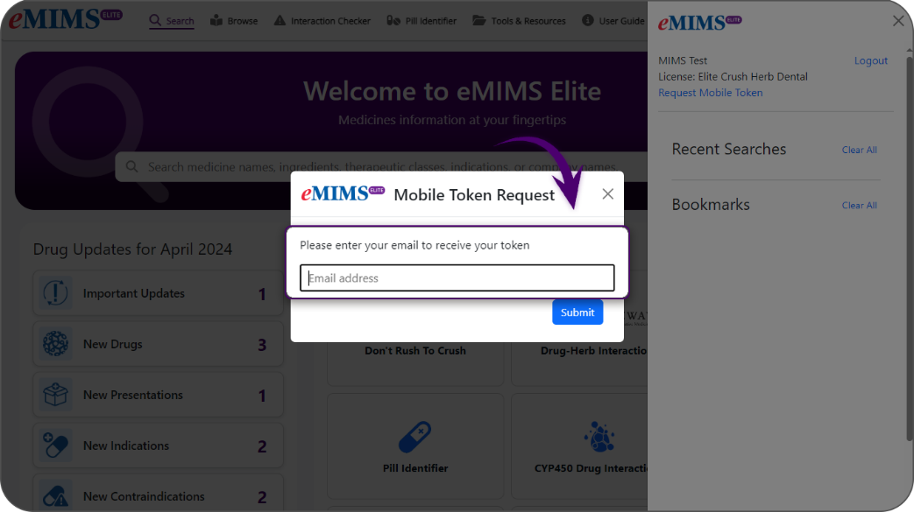

1. You’ll receive a token via mail in the email address entered by you.
2. Log in to eMIMSelite mobile app by entering the token in the mobile app.

**-------------------------------------------OR-------------------------------------------**

1. Access the app on your mobile device.
2. Enter your registered email address and password to login to the app.

**To access the data in *Offline Mode* (without active internet connection):**

1. Access the eMIMSelite app on your mobile device.
2. Login to the app.
3. 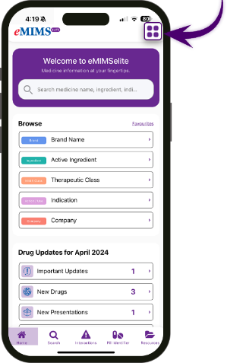Click on the four squared icon on the top tight corner of the app interface.
4. A dialogue box will open, click on the ‘Switch to Offline mode’ button.

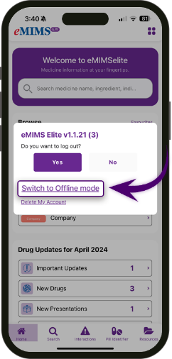

1. Another dialogue box will open which prompts that the user is currently in ‘Online Mode’ and selecting offline mode would require data download. Click on ‘Offline Mode’ button.

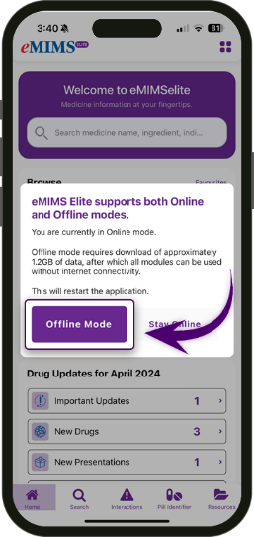

1. 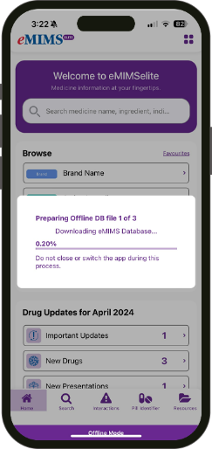This would restart the app after the data download which allows the user to access the content without an internet connection.
2. 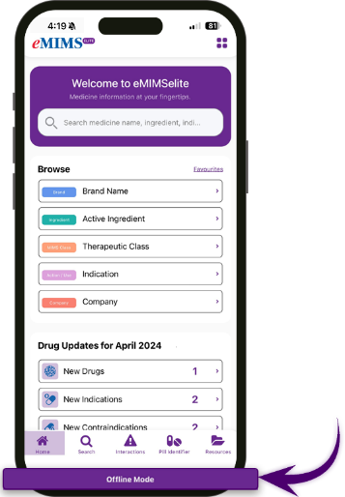After the data download, the user can now access the contents of the app in offline mode even with or without internet connection.